Project Checkpoint 1

1. Design Ideas, Sitemap, Wireframes
Topic: Responsible Consumption and Production
Design Concept: A clean, minimalistic layout emphasizing sustainability and eco-friendly awareness.
Pages:
1. Home: Introduction to responsible consumption and project overview.
2. Blogs/Articles: Articles about sustainability and case studies of responsible businesses.
3. Tips/Solutions: Daily life sustainable consumption tips and production practices.
4. Contact: Contact form and social media links.
Below is the sitemap and project design reference:
- This is the sitemap:
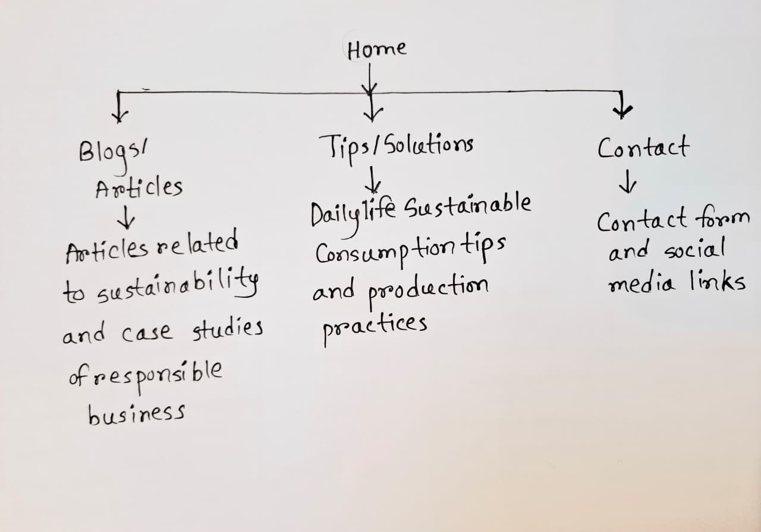 (This made by Sudad Tamim Rahman)

- This is wireframe

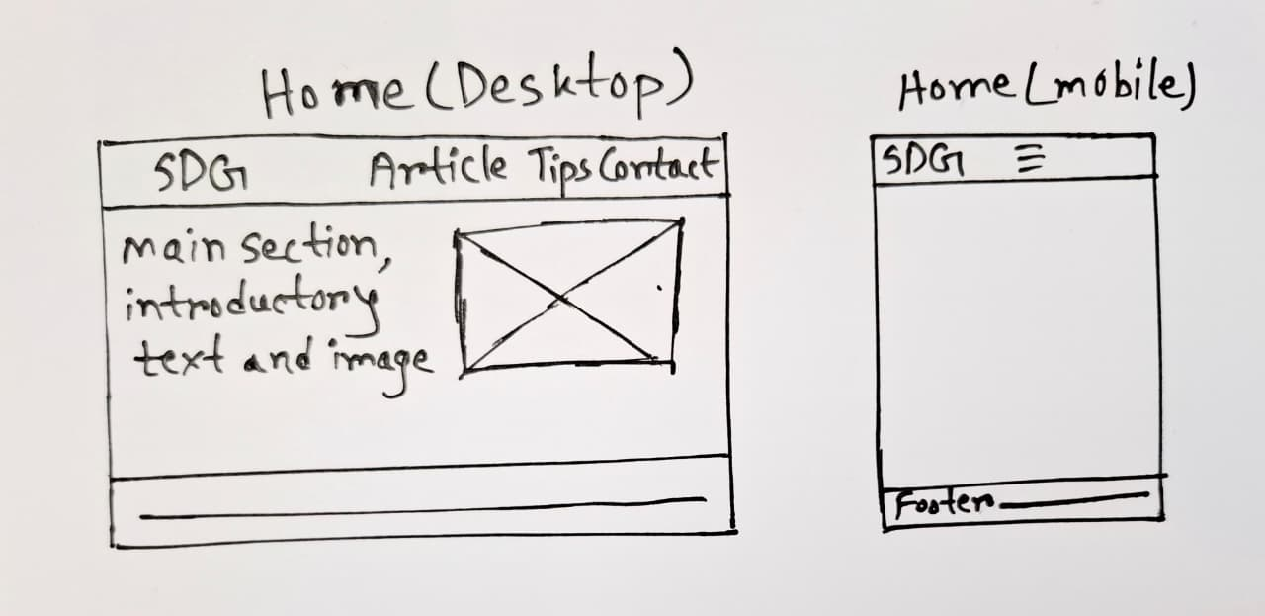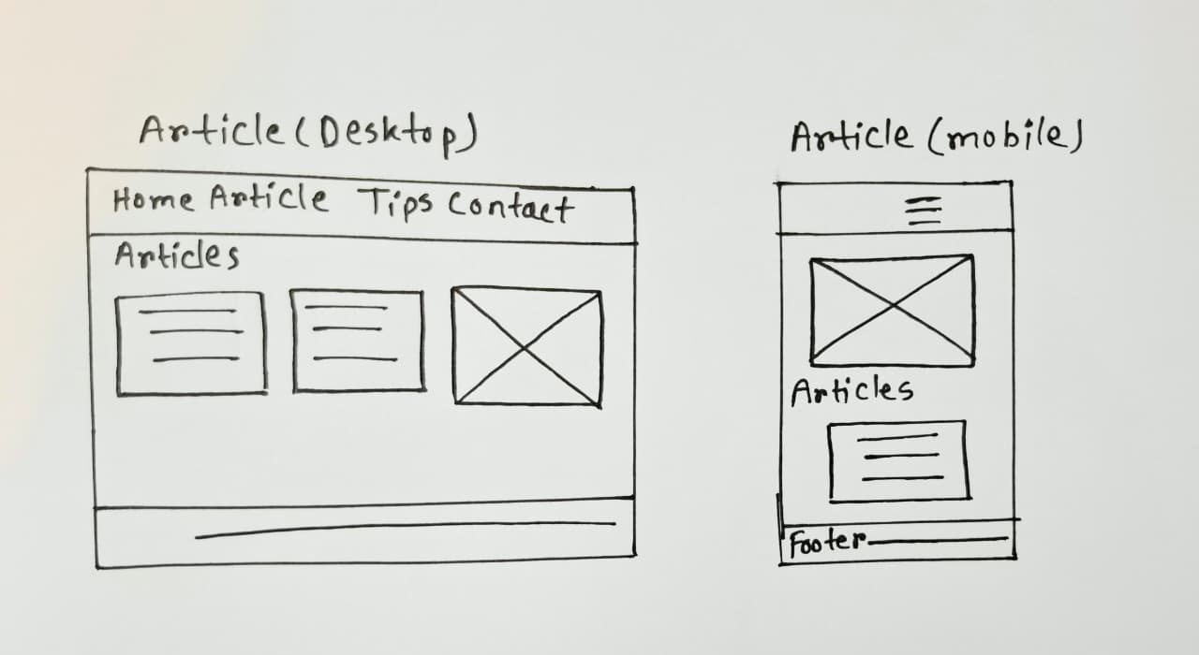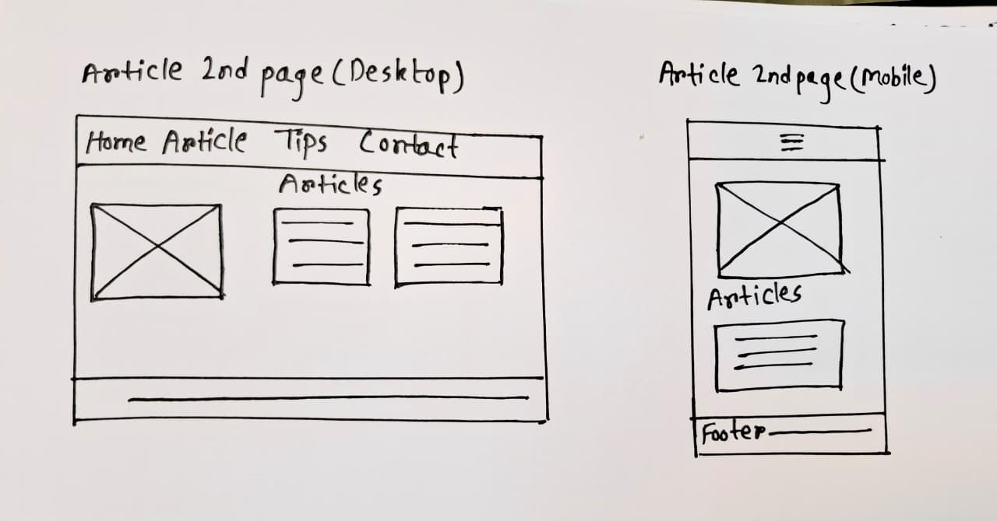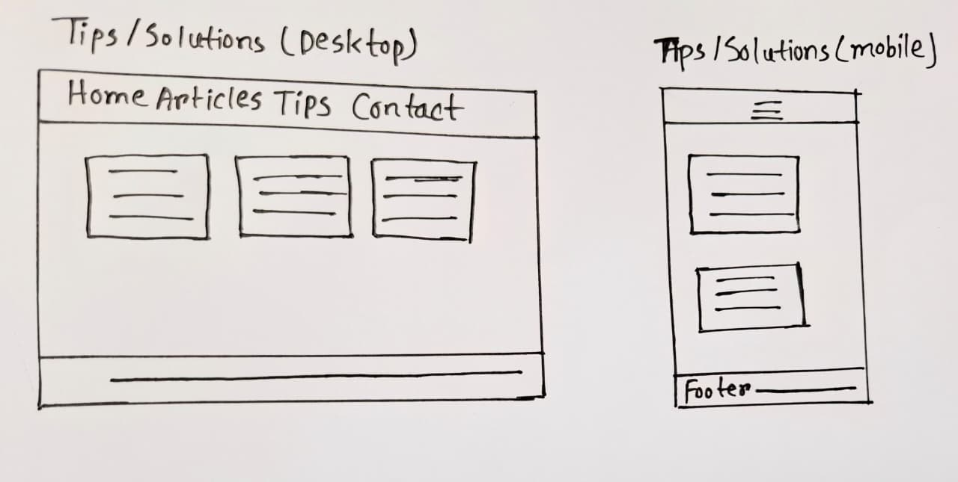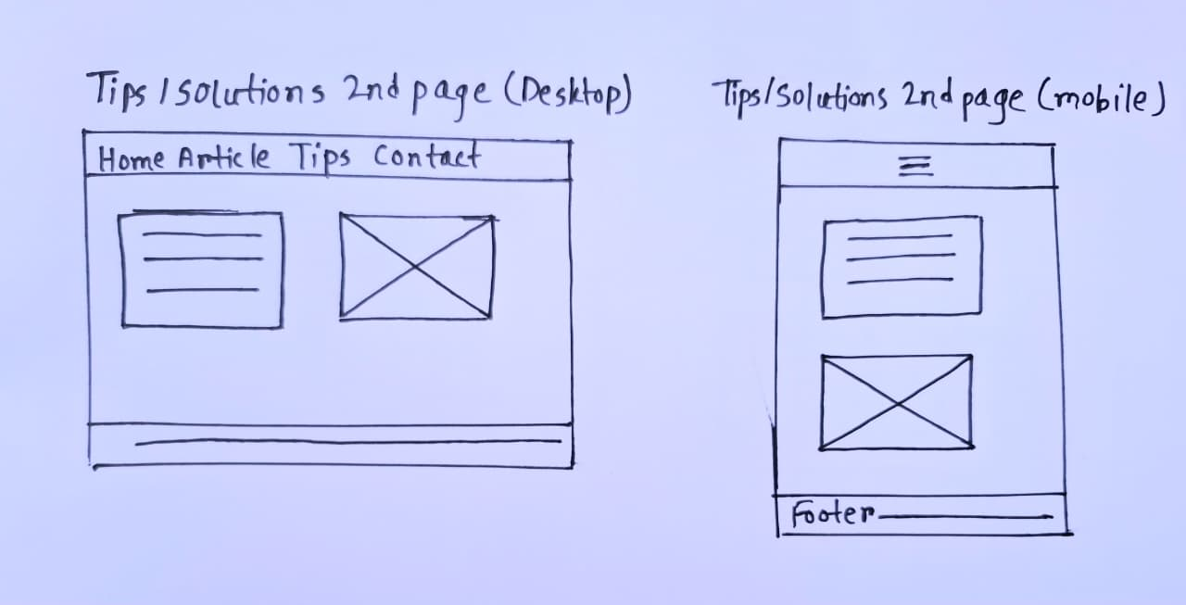
(This made by Sudad Tamim Rahman)
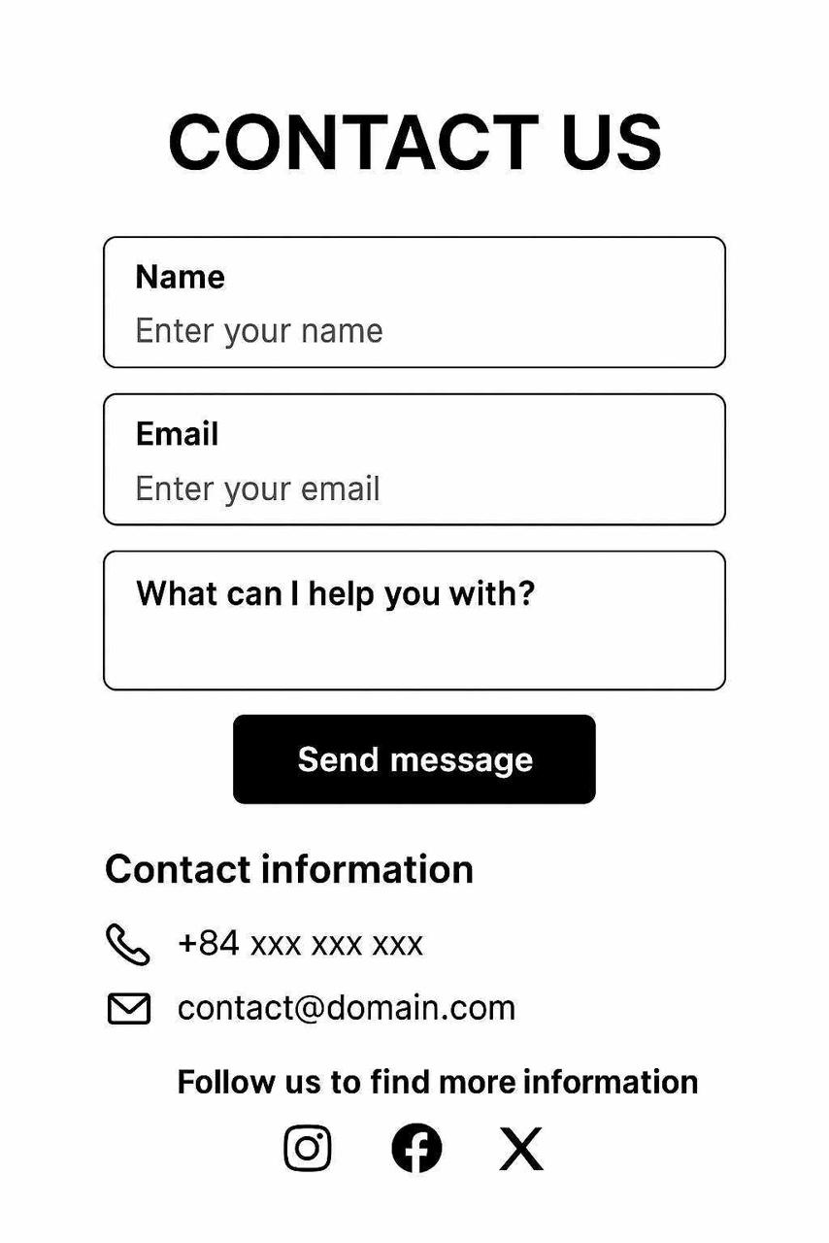
(This made by Nguyen Hai Anh)

2. Task Distribution (Excel-style Table)
Week | Task | Assigned To | Description
Week 8 | Create sitemap and design wireframes | Nguyen Hai Anh  Zadid Uz Zaman  Sudad Tamim Rahman | Designed sitemap structure and wireframes for Contact section
Week 8 | Research and write page content (Home & Blogs) | Tamim Rahman | Drafted homepage intro and sustainability article examples
Week 8 | Build GitHub repository and coordinate project setup | Nguyen Hai Anh | Created GitHub repo and managed project organization
Week 9 | Complete wireframes and finalize design mockups | Nguyen Hai Anh  Zadid Uz Zaman Sudad Tamim Rahman | Finalize all page wireframes and visual structure
Week 9 | Add textual content and visuals | Tamim Rahman | Add textual content for Blogs, Tips pages
Week 9 | Upload to GitHub and check links | Nguyen Hai Anh | Ensure repository readiness and submission

